CitySolution: A Decentralized Smart City
Incident Management platform
¹M. Praveen, ²D. Rohith, ³T. Swetha, ⁴K. Naveen, ⁵ P. Satish Kumar
¹22341a4232@gmrit.edu.in ²22341a4207@gmrit.edu.in ³22341a4258@gmrit.edu.in
⁴22341a4216@gmrit.edu.in ⁵satishkumar.p@gmrit.edu.in
^{1,2,3,4}Student, ⁵Assoc. Professor
Department of CSE (Artificial Intelligence & Machine Learning), GMRIT, Rajam, AP

Abstract:
Rapid urbanization has increased the complexity of managing civic issues such as waste disposal, road damage, and traffic congestion. Conventional centralized reporting mechanisms often experience inefficiencies, limited scalability, and weak public accountability. To address these limitations, CitySolution introduces a decentralized, web-based incident management platform that enables citizens to submit and monitor civic reports in real time. Each submission includes key details - such as geolocation, category, description, and supporting images - which are securely stored and processed through blockchain technology for immutable record keeping. Images are managed via the Inter Planetary File System (IPFS) to ensure distributed and tamper-resistant storage. The platform also integrates community voting, role-based access control, and status tracking to strengthen transparency and participation. Furthermore, an analytics dashboard visualizes trends and statistics, supporting data-driven decisions for civic authorities. The prototype currently employs an in-memory database for demonstration but can be extended to persistent data systems. Overall, CitySolution demonstrates how decentralized technologies and citizen engagement can foster accountable, efficient, and transparent urban governance.
Keywords: Centralized, Blockchain, Inter Planetary File System (IPFS), City Solution, Tamper-Resistant Storage.
Introduction:
The rapid growth of urban population has amplified several civic challenges, including inefficient waste collection, traffic congestion, flooding, and deteriorating public infrastructure. These issues not only disrupt daily activities but also weaken the effectiveness and credibility of local administrations. Traditional incident reporting systems are typically centralized, hierarchical, and time-consuming, which often leads to delays, poor citizen engagement, and limited transparency in the resolution process.
As cities move toward smart and connected governance, there is a growing need for platforms that empower citizens to actively participate in problem reporting and monitoring. CitySolution addresses this need through a decentralized, web-based framework designed to handle real-time civic issue submission, tracking, and management. The system employs a Node.js (Express) backend combined with a React.js frontend to deliver a responsive and user-friendly interface. Citizens can register and report incidents by providing details such as category, description, image, and geolocation, ensuring structured and accurate data collection.
To maintain data security and trust, the platform integrates blockchain technology for immutable record keeping and Inter Planetary File System (IPFS) for decentralized media storage. Each report is authenticated through JSON Web Tokens (JWT) and managed using role-based access control (RBAC) to prevent unauthorized actions. An interactive analytics dashboard further enhances administrative efficiency by presenting live visualizations, including issue trends, user activity, and category-wise distributions.
The current implementation of CitySolution functions with an in-memory database for testing purposes but is designed to easily integrate with scalable, persistent data storage systems. By combining decentralization, transparency, and citizen participation, CitySolution establishes a robust foundation for smart urban governance, promoting accountability, efficiency, and community-driven decision-making.
1. Literature Survey:
A range of studies in recent years has explored intelligent and decentralized approaches for managing urban incidents, reflecting the growing interest in smart city governance and citizen participation. Mónica Aguilar Igartua et al. (2020) introduced INRISCO, a framework that leverages citizen devices, vehicles, and social media to function as real-time sensors for community incident detection. Their system integrates structured and unstructured data to improve anomaly detection and situational awareness through big data analytics, enabling faster and more informed responses to urban challenges. Luís B. Elvas et al. (2020) performed a large-scale analysis of over six thousand incidents reported in Lisbon, including fires and infrastructure failures. Using the CRISP-DM data-mining methodology, the authors demonstrated how statistical modelling and visualization techniques such as heatmaps can help identify spatial and environmental correlations among urban risks.
In a related direction, Eduardo Felipe Zambom Santana et al. (2016) outlined the architectural requirements of software platforms for smart cities. Their proposed unified framework emphasized interoperability, scalability, and real-time data processing, laying the foundation for future integrated urban management systems. El-hacen Diallo et al. (2024) proposed a decentralized reporting model built on blockchain, where each citizen submission is verified and stored immutably using smart contracts. This approach significantly enhances data reliability, eliminates duplicate reports, and strengthens trust between citizens and authorities. Advances in artificial intelligence have also influenced civic issue detection. Shanu Kumar et al. (2019) employed an adversarial scene graph model that uses object detection and relational reasoning to identify and interpret civic problems from images. Their work demonstrated how AI can capture spatial relationships and improve the accuracy of issue classification.
J. González-Villa et al. (2024) designed a decision-support system that integrates sensor data, citizen inputs, and social media to assess safety risks in real time. Their framework combines predictive analytics and visualization dashboards to aid authorities in risk forecasting and resource allocation. Similarly, Dario Rodríguez-García et al. (2021) developed CrowDSL, a distributed platform that enables collective reporting and verification of incidents through crowdsourcing. The system uses task allocation strategies to validate citizen reports efficiently, optimizing response time and resource management. Farhatun Shama et al. (2024) presented a blockchain-enabled mobile application, also named CitySolution, that combines deep learning-based image classification with decentralized storage. Their design highlights the potential of integrating AI and blockchain to enhance transparency and prioritization in civic complaint handling.
Mohammad Dib et al. (2025) proposed a blockchain-based trust framework aimed at securing smart city IoT networks. Their model focuses on ensuring data integrity and accountability through tamper-proof communication between sensors, citizens, and authorities.
Luke Summers et al. (2020) developed a decision-support platform for disaster response using real-time sensors and predictive modelling. This system provides situational awareness and automates resource distribution during emergencies, demonstrating the importance of data fusion in urban resilience. Further, Mohammad Dib et al. (2019) introduced Block IPFS, which combines blockchain and IPFS to guarantee verifiable, traceable, and scalable data management in smart city infrastructures. The fusion of these technologies addresses the challenge of storing large civic datasets securely and transparently. Mohammad Jlil et al. (2024) implemented a blockchain-based mobile system for traffic incident reporting, ensuring that verified cases are immutably recorded and that notifications reach authorities instantly.
In another contribution, Mohammad Dib et al. (2023) proposed a decentralized edge-AI infrastructure capable of local data processing for public safety monitoring. By minimizing latency and reducing dependency on centralized servers, this approach supports real-time responsiveness. Mohammad Dib et al. (2024) also examined the integration of blockchain and federated learning for cybersecurity in smart city environments, emphasizing privacy-preserving model training and secure data exchange across IoT nodes. Finally, Luke Summers et al. (2020) emphasized that the combination of artificial intelligence, blockchain, and IoT technologies can dramatically improve decision-making processes in disaster management. Their model showcased how predictive analytics and integrated communication systems enhance early risk detection and coordinated emergency response.
Collectively, these studies illustrate the evolution of smart city solutions toward decentralized, intelligent, and citizen-oriented systems. The insights derived from this body of research directly inform the design of CitySolution, which seeks to integrate blockchain, IPFS, and data analytics for efficient, transparent, and participatory urban incident management.
2. Methodology:
2.1 Citizen Interaction
The CitySolution platform is designed to provide an intuitive and accessible interface that encourages citizens to report the civic problems such are like potholes, garbage accumulation, drainage blockages etc., The frontend, developed using React.js, HTML, and CSS, communicates seamlessly with a Node.js (Express) backend to ensure smooth and responsive data exchange. When a citizen submits a report, they provide essential details—such as the issue category, description, image, and geolocation coordinates—automatically tagged with a timestamp for accuracy. This real-time reporting process strengthens civic participation by allowing users to contribute directly to improving their surroundings while supplying city administrators with valuable, location-specific data for analysis.
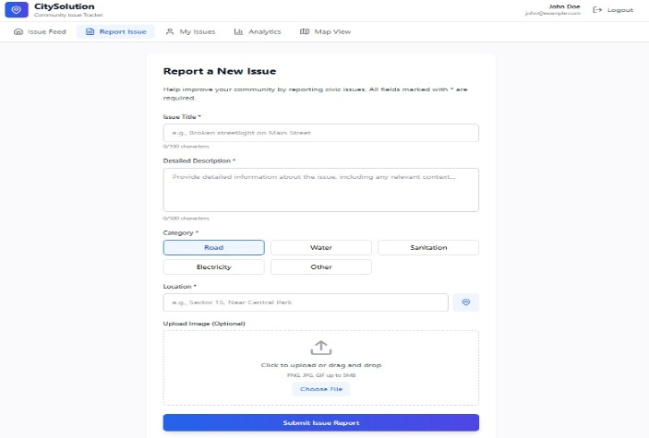
Fig 2.1.1: Interactive Page for Users
2.2 Data Management and Blockchain Integration
Once a report is submitted, the backend processes and stores the information securely through JWT-based authentication and Role-Based Access Control (RBAC) to ensure only for authorized accessed people. Each incident’s metadata—such as type, timestamp, and location—is stored in a MySQL relational database for structured retrieval and analysis. To uphold data transparency and immutability, verified reports are written onto a blockchain ledger, where smart contracts validate each submission and prevent duplication or falsification. In parallel, associated media files (e.g., images) are uploaded to the Inter Planetary File System (IPFS), providing a decentralized, tamper-resistant storage that scales efficiently with growing data volumes. This integration of blockchain and IPFS ensures trust, auditability, and long-term data preservation within the civic reporting ecosystem.
2.3 Output Generation and Visualization
After the successful verification and recording of incidents, the platform generates dynamic reports summarizing crucial information such as incident type, location, submission time, and current status. Administrators and authorized personnel can access an interactive analytics dashboard that provides real-time visualizations, including heatmaps, frequency distributions, and issue trends. The dashboard supports multiple filtering options by category, severity, or location, enabling decision-makers to prioritize issues effectively.
Furthermore, embedded statistical tools reveal community voting trends, report resolution rates, and user participation metrics—allowing data-driven planning and resource allocation for city authorities.
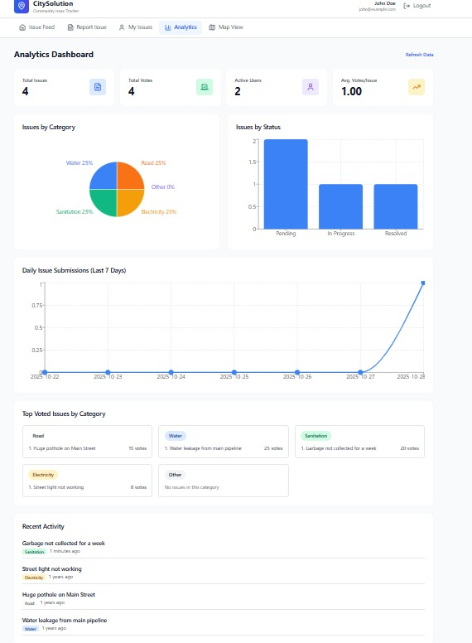
Fig 2.3.1: Output Generation and Visualization
2.4 Workflow Overview
The CitySolution workflow begins when citizens submit reports via the web interface. The backend authenticates the user, validates the data, and records the verified report on the blockchain ledger. Uploaded images are simultaneously stored on IPFS, and all incident details are made accessible through the administrative dashboard. This modular and scalable architecture ensures continuous synchronization between components, resulting in transparent data management, enhanced scalability, and improved accountability. By combining decentralized storage, secure authentication, and real-time visualization, CitySolution demonstrates a comprehensive model for next-generation digital governance and civic management.
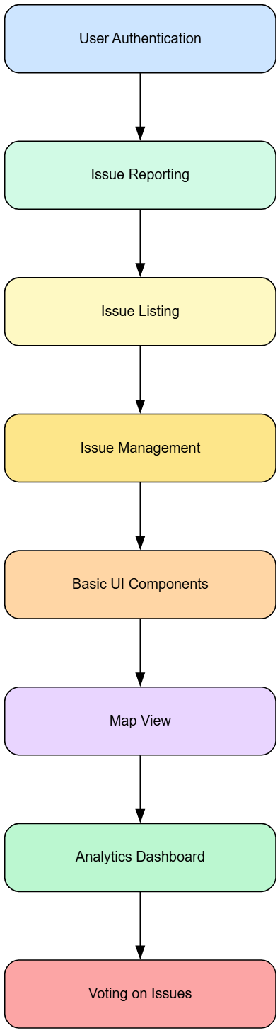
Fig 2.4.1: Workflow of the Project
3.Results & Conclusion:
3.1 Demonstrated Feasibility and System Performance
The developed CitySolution prototype successfully demonstrates the viability of a decentralized reporting framework for smart city governance. The integration of React-based frontend, blockchain ledger, and IPFS storage confirms that the proposed system can securely handle and manage large volumes of civic data in a transparent and scalable manner. The complete workflow—from incident submission to verification and display on the dashboard—was implemented using well-defined APIs. This ensures smooth data exchange, integrity, and real-time traceability of citizen reports. The use of IPFS significantly improves scalability by offloading large media files from the blockchain, thereby maintaining system efficiency. For an estimated 10⁸ incident records, the combined storage requirement remains under 200 GB, demonstrating the compactness of the design.
User testing indicates that the interface is intuitive and responsive, providing citizens with location-based reporting through GPS integration and map visualization. The built-in voting mechanism enables collective validation of incidents, strengthening the participatory nature of the system and creating opportunities for future incentive-based engagement. From a performance perspective, adopting the Quorum blockchain (Raft consensus) architecture resulted in an average latency below 15 seconds and throughput between 200–500 transactions per second (TPS). These results indicate that the framework can support near real-time updates, outperforming traditional centralized architectures in both responsiveness and data integrity.
Parameter | Measured Value | Technology Used
Throughput | 200–500 TPS | Quorum (Raft Consensus)
Latency | < 15 seconds | Quorum Blockchain
Estimated Storage (10⁸ incidents) | < 200 GB | Blockchain + IPFS
Table 3.1.1: System Performance Summary
Conclusion:
The CitySolution framework presents an innovative and practical approach to decentralized urban incident management. By merging Blockchain, IPFS, and a React-based decentralized application (DApp), it establishes a secure, transparent, and citizen-focused reporting ecosystem. The system ensures a complete incident life cycle—from data submission and validation to visualization and analysis—while maintaining data integrity and privacy.
Compared with conventional centralized models, CitySolution demonstrates substantial improvements in accountability, data transparency, and operational scalability. The immutable nature of blockchain records and distributed image storage enhances trust and reliability in civic governance.
For future work, the project aims to implement a Reputation and Incentive Model through smart contracts, rewarding citizens for valid and verified reports. Additional research will focus on integrating AI-driven analytics for automated issue classification and trend detection, as well as extending the system to support large-scale real-world deployments. Improvements to user experience, feedback collection, and adaptive dashboards will also contribute to the platform’s long-term sustainability and impact.
References:
- M. A. Igartua et al., "INRISCO: INcident monitoring in Smart Communities," in IEEE Access, vol. 8, pp. 72435-72460, 2020, doi: 10.1109/ACCESS.2020.2987483.
- L. B. Elvas, C. F. Marreiros, J. M. Dinis, M. C. Pereira, A. L. Martins, and J. C. Ferreira, "Data-Driven Approach for Incident Management in a Smart City," Applied Sciences, vol. 10, no. 22, p. 8281, Nov. 2020, doi: 10.3390/app10228281.
- E. F. Z. Santana, A. P. C. Steinmacher, M. A. Gerosa, F. Kon, and D. Milojicic, "Software platforms for smart cities: Concepts, requirements, challenges, and a unified reference architecture," ACM Computing Surveys, vol. 50, no. 6, pp. 1-37, Jan. 2018, doi: 10.1145/3124391
- Diallo, E. H., Abdallah, R., Dib, M., & Dib, O. (2024). “Decentralized incident reporting: Mobilizing urban communities with blockchain”. Smart Cities, 7(4), 2283-2317.doi.org/10.3390/smartcities7040090
- S. Kumar, S. Atreja, A. Singh, and M. Jain, "Adversarial adaptation of scene graph models for understanding civic issues," in Proceedings of the 2019 World Wide Web Conference (WWW '19), San Francisco, CA, USA, pp. 2943-2949, 2019, doi: 10.1145/3308558.3313681.
- J. González-Villa, A. Cuesta, M. Spagnolo, et al., "Decision-support system for safety and security assessment and management in smart cities," Multimedia Tools and Applications, vol. 83, pp. 61971–61994, 2024, doi: 10.1007/s11042-023-16020-6.
- D. Rodríguez-García, V. García-Díaz, and C. González García, "CrowDSL: platform for incidents management in a smart city context," Big Data and Cognitive Computing, vol. 5, no. 3, p. 44, 2021, doi: 10.3390/bdcc5030044.
- F. Shama, A. Aziz, and L. B. M. Deya, "CitySolution: A complaining task distributive mobile application for smart city corporation using deep learning," SoftwareX, vol. 27, p. 101829, 2024, doi: 10.1016/j.softx.2024.101829.
- R. Islam, R. Bose, S. Roy, et al., "Decentralized trust framework for smart cities: a blockchain-enabled cybersecurity and data integrity model," Scientific Reports, vol. 15, p. 23454, 2025, doi: 10.1038/s41598-025-06405-y.
- D. Jung, V. Tran Tuan, D. Quoc Tran, M. Park, and S. Park, "Conceptual framework of an intelligent decision support system for smart city disaster management," Applied Sciences, vol. 10, no. 2, p. 666, 2020, doi: 10.3390/app10020666.
- E. Nyaletey, R. M. Parizi, Q. Zhang and K. -K. R. Choo, "BlockIPFS - Blockchain-Enabled Interplanetary File System for Forensic and Trusted Data Traceability," 2019 IEEE International Conference on Blockchain (Blockchain), Atlanta, GA, USA, 2019, pp. 18-25, doi: 10.1109/Blockchain.2019.00012.
- M. Jlil, K. Jouti, J. Boumhidi and C. Loqman, "Blockchain-Based Mobile Application for Traffic Accident Report's Management," 2024 4th International Conference on Innovative Research in Applied Science, Engineering and Technology (IRASET), FEZ, Morocco, 2024, pp. 1-6, doi: 10.1109/IRASET60544.2024.10548282..
- D. Cetinkaya, J. González-Villa, M. Zanotti, A. Cuesta, and M. Spagnolo, “Decentralized Edge-AI Infrastructure for Public Safety in Smart Cities: A Real-Time Response Model,” IEEE Internet of Things Journal, 2024.
- Sefati, S. S., Craciunescu, R., Arasteh, B., Halunga, S., Fratu, O., & Tal, I. (2024). “Cybersecurity in a scalable smart city framework using blockchain and federated learning for internet of things (iot)”.Smart Cities, 7(5), 2802-2841.doi.org/10.3390/smartcities7050109
- IJung, D., Tuan, V. T., Tran, D. Q., Park, M., & Park, S. (2020). “Conceptual Framework of an Intelligent Decision Support System for Smart City Disaster Management”. Applied Sciences, 10(2), 640. doi: 10.3390/app10020640.

